

TOWN OF HEBRON
PARADE

SATURDAY – APRIL 1, 2023 @ 12:00 P.M.

PARADE Starts at Westside Intermediate School and end at the Hebron Lions Club Ballpark
(NOTE: You must REGISTER to be in parade. Arrive at Westside Intermediate School between 11:00 – 11:30 am. to line up)
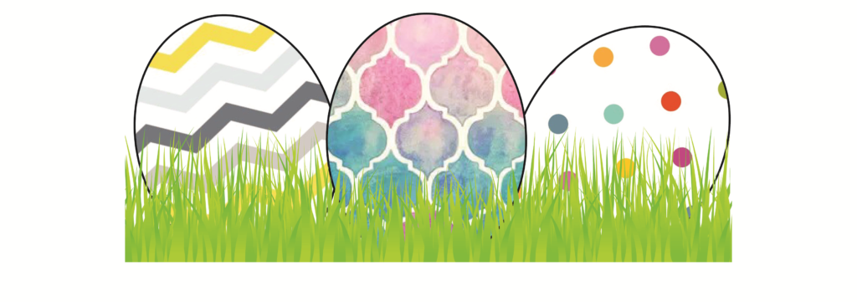
EASTER EGG HUNT
Immediately following the parade at the
Hebron Lions Club Ballpark
Sponsored by Hebron Lions Club

TO REGISTER OR IF YOU NEED MORE INFORMATION CONTACT:
Ken Pick (410-390-1162), Amelia Handy (443-366-1576) or
Chester Sebald (443-618-1317)

Please return registration form to Town Hall by Wednesday, March 29, 2023
or via E-MAIL to: kenlpick@comcast.net



Looking forward to your participation

